St. John’s Primary
Bligh’s Lane
Derry

A Policy for Period Dignity 2026

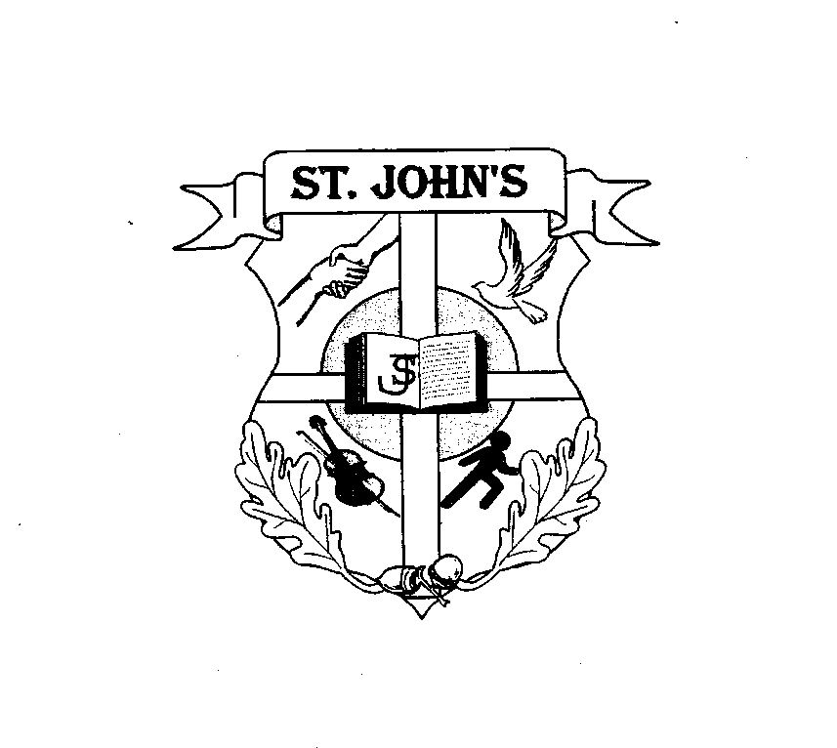

“Learning Together Growing Together”

Mission Statement
At St. John’s Catholic, Primary School (PS), we provide a happy, nurturing, inclusive, learning, environment which delivers high quality outcomes and life-enriching experiences. We embrace diversity and encourage all to respect the environment and develop the confidence and digital skillset required to contribute to society and the local and global economy. We work collaboratively with parents/carers and community partners to promote the social, emotional, intellectual, and spiritual well-being of each individual, thereby enabling our school family to ‘Learn Together’ and ‘Grow Together.’
Rationale
The rationale for this policy is taken from CCEA, Period Dignity Policy/Guidance September 2021 and Relationships and Sexuality Education – Guidance Document Catholic Schools Trustee Service 2021.

Period Dignity Statement

What is Period Dignity?
1. Period dignity refers to the accessibility and availability of essential care needed to support a period, in conjunction with the removal/breaking of stigma and taboo around periods. Education is a key factor in breaking the stigma surrounding periods and promoting respect, understanding and open discussions about what people may experience when menstruating.

2. Period poverty generally refers to poor menstrual knowledge and/or access to period products. Plan International describes what it calls a toxic trio of: -
• the cost of sanitary products;
• a lack of education about periods; and,
• shame, stigma and taboo.

Period dignity is a cross-cutting issue and, if addressed, has the capacity to benefit thousands of people.

There have been significant developments in relation to schemes to provide free period products and promote period dignity through education programmes in schools and other educational establishments.

On 17 December 2020, the NI Executive funded a programme to provide free period products to all schools in Northern Ireland with effect from September 2021. The pilot scheme addresses the specific needs of the school sector and is supported with curriculum materials and an online Teacher Professional Learning programme for schools, thereby improving period dignity through addressing all three elements of Plan International’s toxic trio.

The free products are not aimed at providing a blanket provision, but the scheme aims to
ensure products are available to menstruating learners where and when they need them.
This policy has been developed using guidance available and is a policy which is relevant to the lives of young people today. RSE, in general, is embedded in the curriculum taught in St John’s PS to help and support young people through their physical, emotional and moral development. Our successful approach to period dignity will help our young people to respect themselves and others and move with confidence from childhood to adolescence.

Why Period Dignity is important:
According to the NHS, most girls start their periods when they are about 12 years old, but
they can start as early as eight years old. It is therefore important to talk to girls and boys
about periods from an early age to make sure they are aware of what is involved and how
girls can be prepared for their first period.

Menstrual wellbeing fits into the Personal Development and Mutual Understanding Area of
Learning at Key Stage 2 under Theme 4: Health, Growth and Change. This includes: -
• knowing how the body grows and develops;
• being aware of the physical and emotional changes that take place during puberty; and
• knowing how babies are conceived, grow and are born.

By teaching all young people together, schools can send a powerful message that periods are not secret or shameful. They are not ‘girls’ business’ and are normal and natural. It is important that boys have knowledge of and understand what girls experience before and during menstruation, and how their mood might change as they go through the menstrual cycle each month. The age of young people and their maturity are given careful consideration.

Information covered:-
• facts about menstruation;
• menstrual wellness – physical and emotional wellbeing leading up to and during periods;
• menstrual hygiene – essential facts and how to deal with related situations; and
• challenges – pain, anxiety, fear, embarrassment and myths.

St John’s Primary School will therefore through teaching and consultation with stakeholders:-
- Ensure that young people, staff and parents/carers understand the term ‘period dignity’;
- Raise awareness of the toxic trio and how this impacts children and young people;
- Promote period dignity in school and ensure that everyone who needs them has free access to period products;
- Ensure that all young people, staff and parents/carers understand the impact of periods on the emotional, mental, social and educational well-being of young people;
- Enable learners to achieve their potential by reducing any barriers they may experience due to periods;
- Reduce stigma/taboo in relation to periods by providing all young people with relevant, age appropriate information on periods;
- Enable learners to understand how to deal with period issues, hygiene and disposal
of period products;
- Promote respect, understanding and open discussion about what people may experience when menstruating; and
- Have a positive impact on confidence, well-being, attendance and attainment.

Respecting the Rights of Children
Northern Ireland, is a signatory to the 1989 United Nations Convention on the Rights of the Child (UNCRC) and has agreed to uphold the rights of children and young people as set out in the convention. This means that all children and young people in Northern Ireland have a right to a good quality education in accordance with the Convention.

Teaching Period Dignity in St John’s Primary School

Approaches to Teaching and Learning
In St John’s Primary School, Ms Lauren Bonner is the appointed Period Dignity Champion. Ms Bonner organises a Year 7 information session annually. Resources used are shared with parents beforehand. Parents also have the option of removing their child from discussions. All Year 7 girls are aware that there are products for their use and teachers are aware of this also. Sanitary bins are provided in a separate toilet available to the girls for privacy. Products are kept in this toilet also.

The ‘Love for Life’ programme is delivered annually allowing the children in Year 7 to discuss all aspects of Relationships and Sexuality Education at an appropriate level. This includes combined and separate puberty talks for the boys and girls. At St John’s PS, this is how we begin to engage boys in the conversation of period dignity.

Teaching Resources
Resources sourced from the ‘Love for Life’ ‘Flourish’ programmes are checked to ensure that they reflect the ethos of the school, are age appropriate, sensitive and inclusive and make clear distinctions between fact and fiction. All teaching resources that are considered sensitive in nature are shared with parents.

CCEA have provided suitable lessons for boys and girls on period dignity and these may also be utilised appropriately in Key Stage 2, as appropriate.

Teaching Sensitive Issues
Sensitive issues are part and parcel of life. Children are aware of them, and want to talk about and understand them, particularly those sensitive issues which are also topical. Young people should not be denied the opportunity to explore such issues simply because a teacher feels uncomfortable discussing them, and they should not be sheltered from discussing sensitive issues in an age-appropriate way. To do either is to leave children ignorant and unprepared to engage and deal with the diverse and complex range of issues facing them in society today. In St John’s Primary School, we will endeavour to support our staff and children when dealing with sensitive issues and topics.

Confidentiality
The Safeguarding Procedures of our school will be followed if any disclosures are made during lessons. Please see our Safeguarding Policy.

Withdrawal from Period Dignity Lessons and Discussions
Parents/carers have the right to have their children educated in accordance with their wishes. Therefore, whilst ‘there is not legislative provision permitting parental withdrawal from sex education’, schools can grant these requests on an individual basis. Our school will them consider how we can support parents/carers who choose to withdraw their child from all or part of the Period Dignity curriculum.

If a parent/carer chooses to withdraw a child from all or part of period dignity lessons, they must discuss the potentially detrimental effect that this can have on the child with the school. They should consider the social and emotional effects of being excluded, as well as the likelihood that the child will hear their peers’ version of what happened or what was said in the classes, rather than the safe and reliable source of the teacher’s. Ultimately, however, the school must respect the wishes of the parent or carer.

Young People with Special Educational Needs (SEN)
Schools must ensure children with SEN in mainstream schools have appropriate, accessible
and relevant Relationships and Sexuality Education. Schools may need to engage in the careful planning and adapting of resources and teaching activities to ensure that there are
no barriers to participation or learning for young people with SEN compared to their peers. It is particularly important that schools communicate with parents/carers of young people with SEN about the content of lessons and the date when classes will cover certain teaching activities/themes. This communication will allow for parents of carers to reinforce learning at home.

When period dignity lessons are being planned, parents of children with SEN will be contacted and provided with additional resources to help them support their child/children
at home. Some examples of resources available are listed below.
- Link to Autism Friendly Guide to Periods
https://wuka.co.uk/products/the-autism-friendly-guide-to-periods
- Visual Booklet to explain periods to girls with SEN.

Responsibilities for Teaching Period Dignity
Responsibility of how the teaching of period dignity in St John’s Primary school will be delivered lies with the Board of Governors and will be decided on consultation with staff, representatives of parents and children.

Ms Bonner is the Co-ordinator of period dignity in our school and will work with the Principal to ensure access to all.

Access to Period Products for Young People
Period products are delivered to the school. Deodorant and wipes are also provided for hygiene purposes. This is the responsibility of the Co-ordinator. All girls have access to a private toilet with products at hand so girls do not need to ask for them. These include spare items of underwear. Period products are brought on school trips.

Stake Holder Consultation
Consultation on provision of period dignity products was conducted in October 2025.

Other Policies
This policy does not stand alone. It should be considered along with the following policies:-
- Anti Bullying Policy
- Safeguarding Policy
- Pastoral Care Policy
- Relationships and Sexual Education Policy
- Positive Behaviour Policy
- Intimate Care Policy
- Educational Trips or Visits.

References
This policy was written with reference to the following documentation: -
- CCEA Guidance on Period Dignity Policy/Guidance September 2021
- Relationships and Sexuality Education – Guidance Document Catholic Schools Trustee Service 2021.
- The Equality Act (Sexual Orientation) Regulations (Northern Ireland) 2006
(www.legislation.gov.uk)
- UNCRC – www.unicef.org.uk
- Relationships and Sexuality Education Policy in Schools – DE Circular 2013/16
- Relationships and Sexuality Education (RSE) Guidance – DE Circular 2015/22
- Guidelines for RSE in Catholic schools - CCMS Circular 2013/19.
- Menstrual Well-being Primary Links – www.ccea.org.uk
Monitoring, Evaluating and Policy Review
This policy will be reviewed regularly to ensure it is fit for purpose by the Co-ordinator, Principal and Board of Governors. This policy will be reviewed in 2029 or in line with new legislation/recommendations.

Signed:___________________________ Date: _______________________
Kathleen McCallion (Ratified at Board of Governors’ meeting)
(Chairperson of the Board of Governors)

